

March Assessment Revision Worksheet
Grade 3 – Mathematics
Name: ____________________ Section: ______________ Date: ____________
UNIT 17: Multiplication and Division
Q1. Solve the following
2 3  × 4  ____ | 4 1  × 3  ____
5 6  × 7  ____ | 8 4  × 6  ____

Q2. Solve the following. Also show the work.

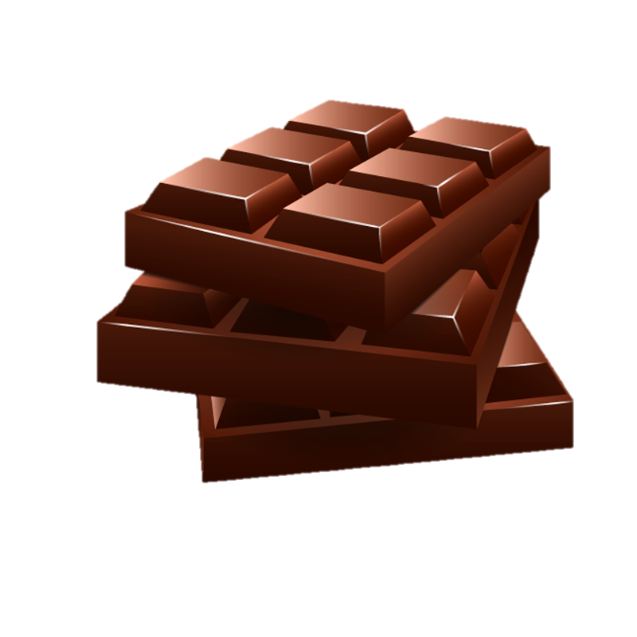
- A box has 6 rows of 8 chocolates.
How many chocolates are there?
___________________________________________________________________________
___________________________________________________________________________
- A school buys 47 notebooks for each of 6 classes.
How many notebooks are bought in total?
___________________________________________________________________________
___________________________________________________________________________
Q3. Solve the following
a)42 ÷ 7 | b)81 ÷ 9
c)96 ÷ 6 | d)144 ÷ 8
Q4. Solve the following problems. Also show the work.
a)48 candies are shared among 6 children.
How many candies does each child get?

___________________________________________________________________________
___________________________________________________________________________
- 167 students are placed into groups of 8.
How many groups can be made?
How many students remain?
___________________________________________________________________________
___________________________________________________________________________

Q5. Andre read 24 pages of a book.

Lucas read 4 times as many pages as Andre.

Circle the number sentence that could be used to find the number of pages Lucas read.

4 × = 24 24 ÷ 4 = 4 × = 24 24 × 4 =
Tip: Check that the number sentence gives the right answer.

Q6. Pierre has 45 model cars.

Pierre has 5 times as many model cars as Yuri has.

How many model cars has Yuri got?
___________________________________________________________________________
___________________________________________________________________________

Q7. There are 24 teams in the 7-a-side football competition.

How many players are in the competition?
___________________________________________________________________________
___________________________________________________________________________

Q8. Mia and Ava put up some tents at a camp. They need 8 pegs to put up one tent.

They have 100 pegs.

How many tents can Mia and Ava put up? How many pegs are left over?

Tip: Mia and Ava may not be able to use all of their pegs.
___________________________________________________________________________
___________________________________________________________________________

Q9. Ahmed has 3 jigsaw puzzles.

Each puzzle has 125 pieces.

How many jigsaw pieces has Ahmed got altogether?
___________________________________________________________________________
___________________________________________________________________________

Q10. Find the odd one out. Explain your answer.

12 ÷ 3 20 ÷ 5 36 ÷ 9

35 ÷ 5 32 ÷ 8

______________________________________________________________________

______________________________________________________________________

